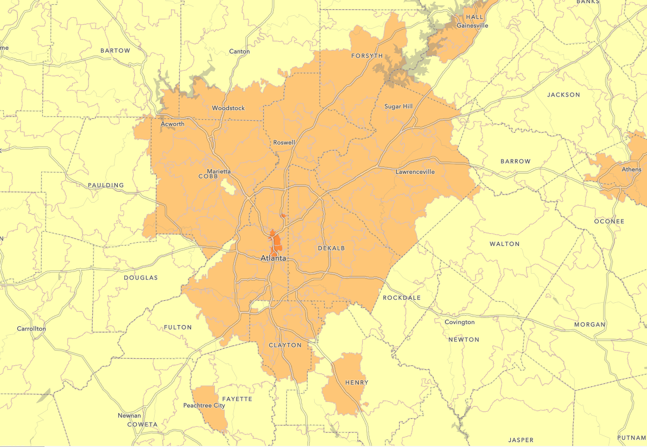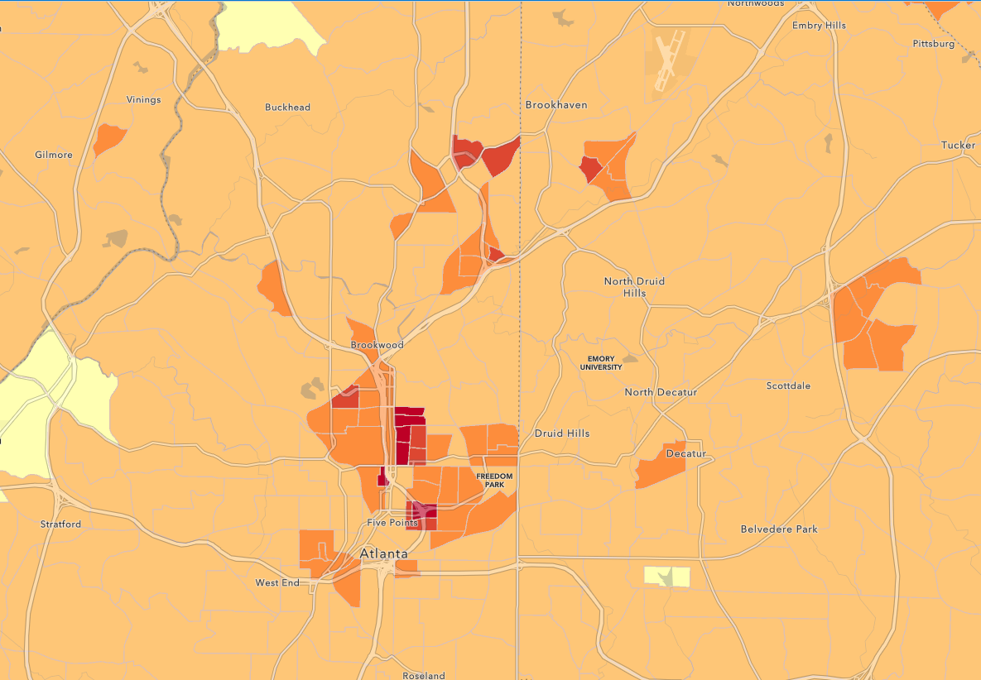

Population of atlanta – more red = more populated

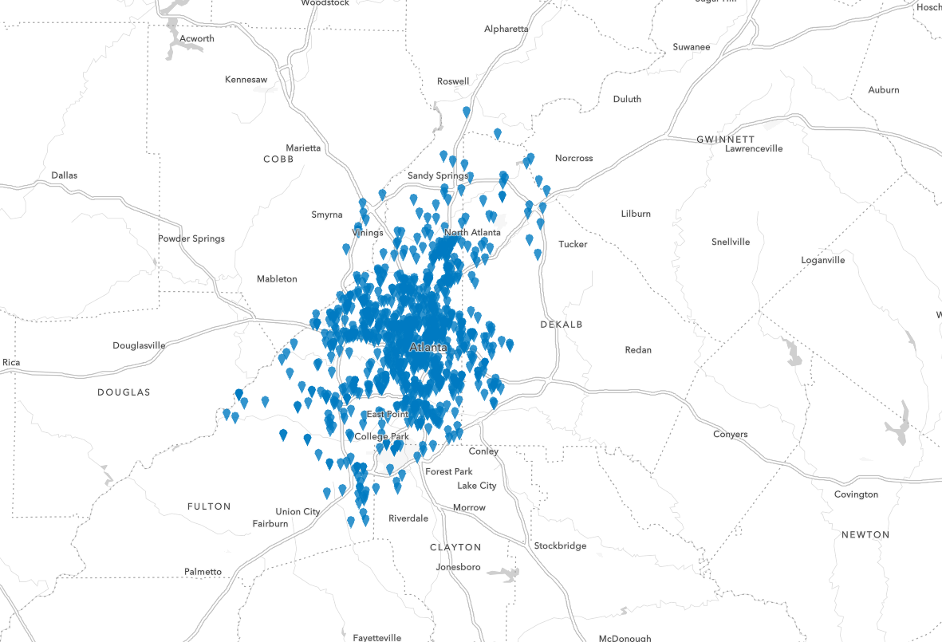

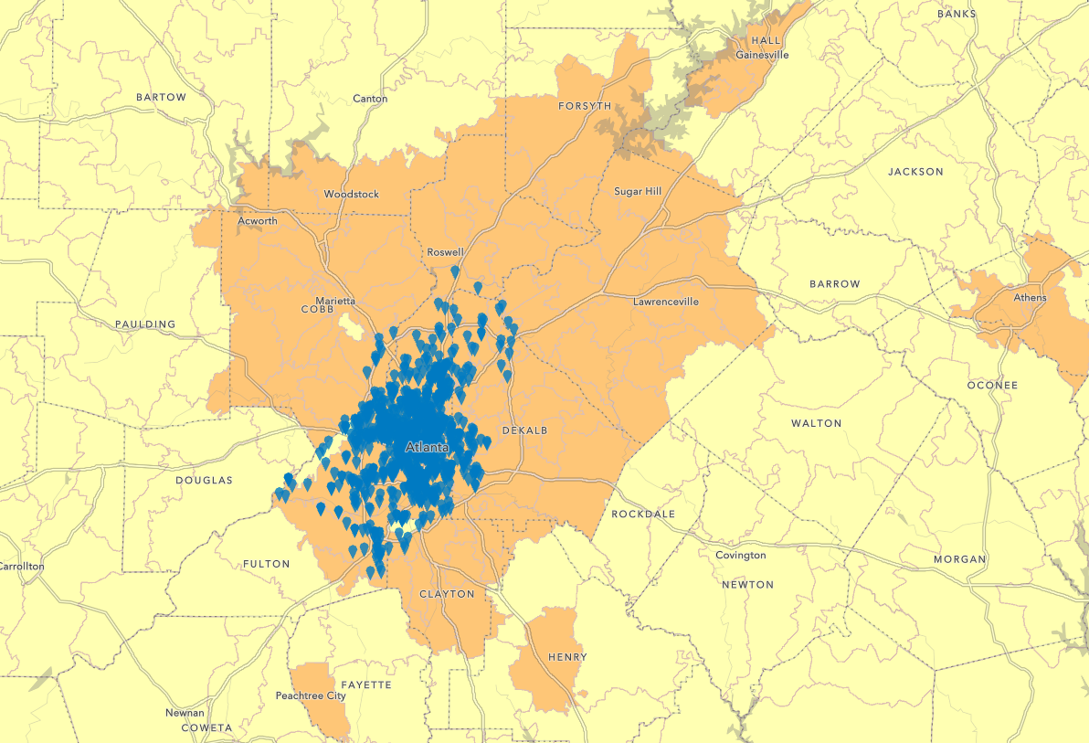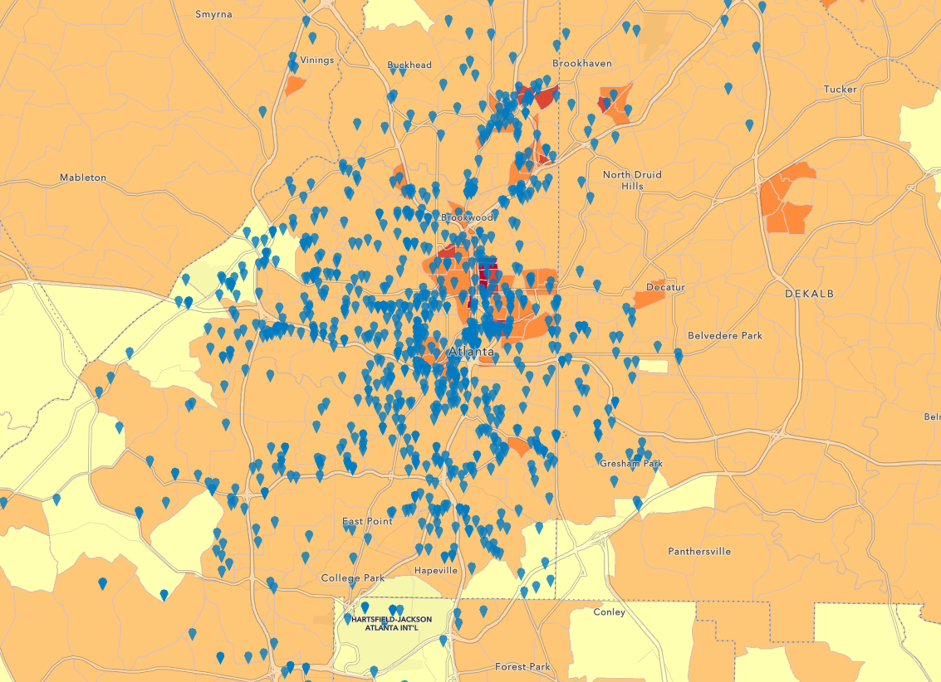

Gun crime atlanta, centered around central surprisingly, where population is not the most (although there is a considerable amount of gun crime in the more populated area of atlanta

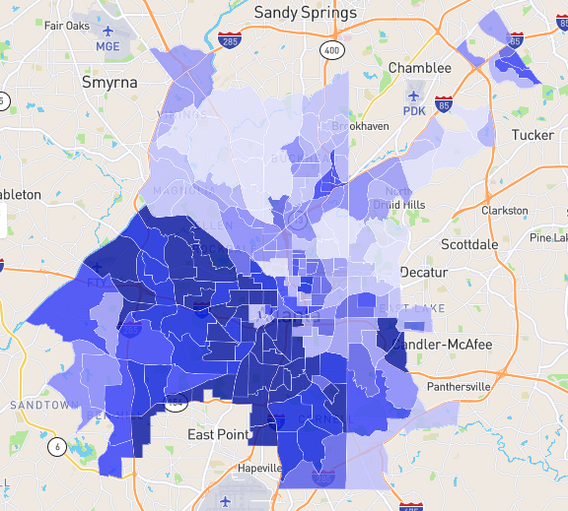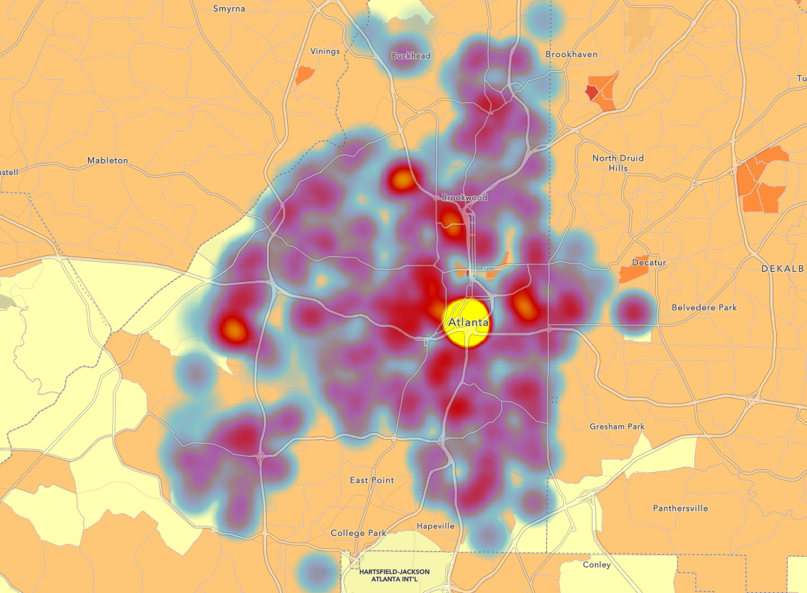

The crime rate also supports this – there is correlation between crime rate, population, and shootings – map is combined excel sheet of crime rate, population, and shooting rate – this is map of dangerous level from 1 - 10 -- <https://www.neighborhoodscout.com/ga/atlanta/crime> -- photoshop together?

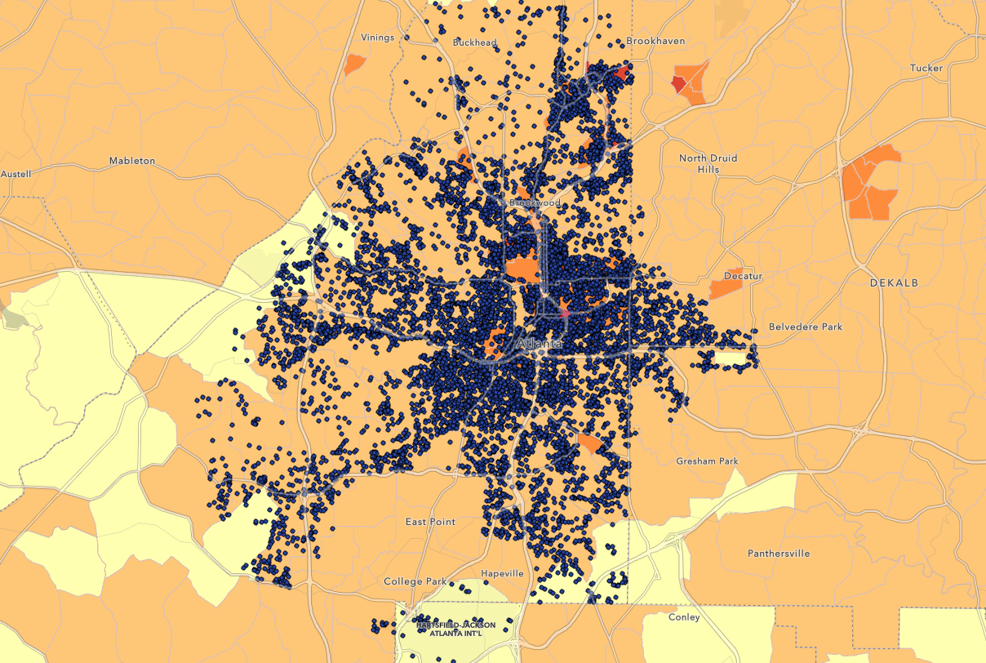

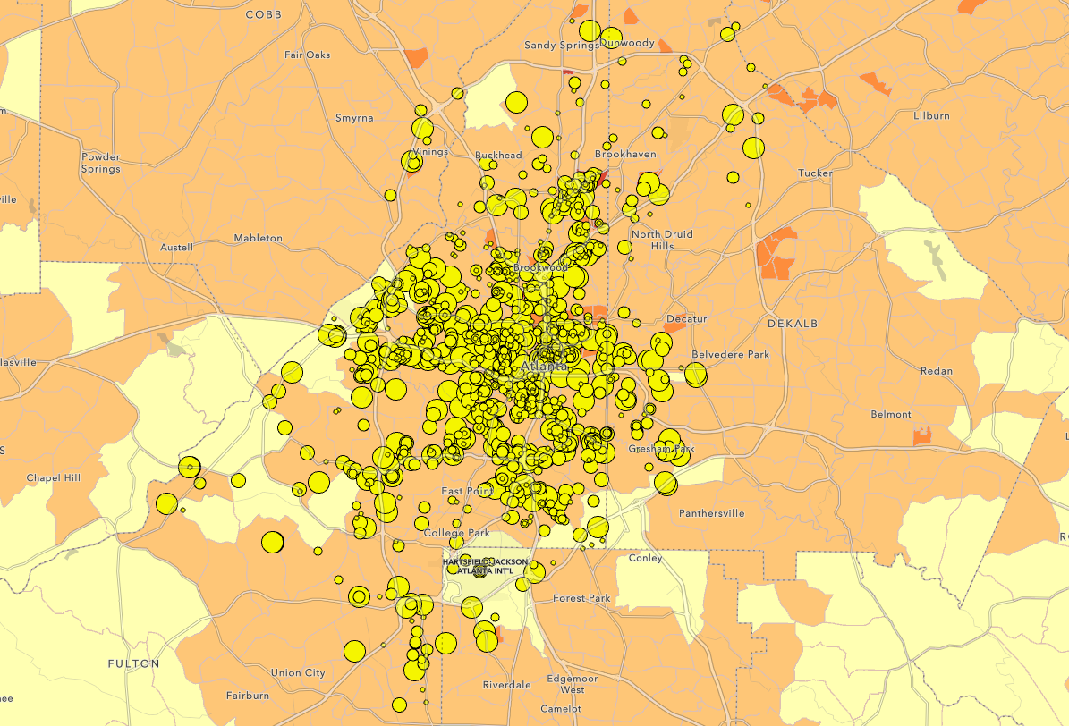

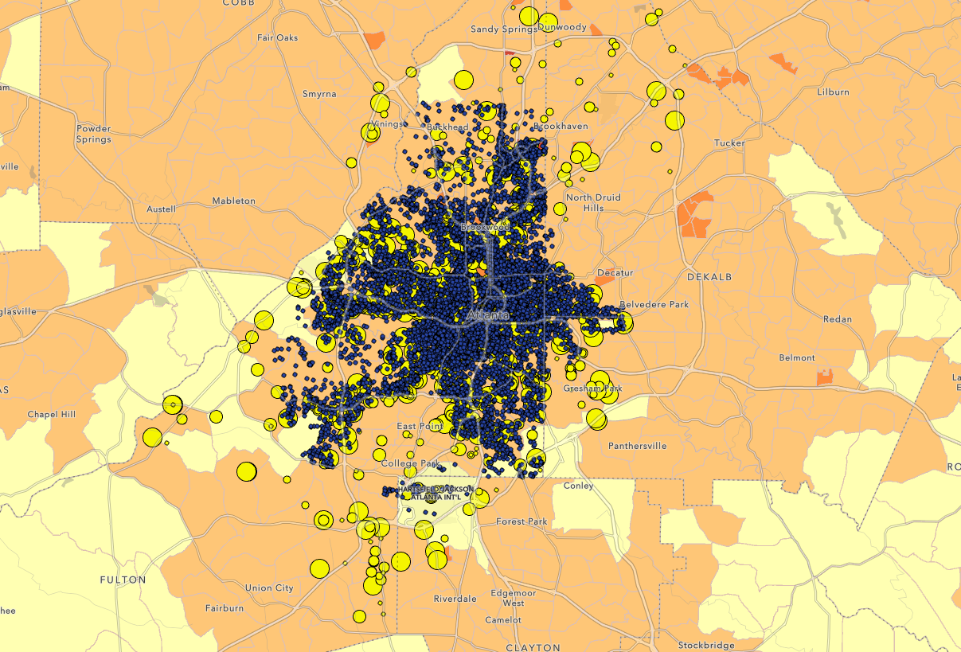

Overall crime rate (including gun). Surprisingly, while crimes are more centered around center atlanta, while gun specific crimes not only center around altanta, but also more around the southwest and northeast of atlanta.

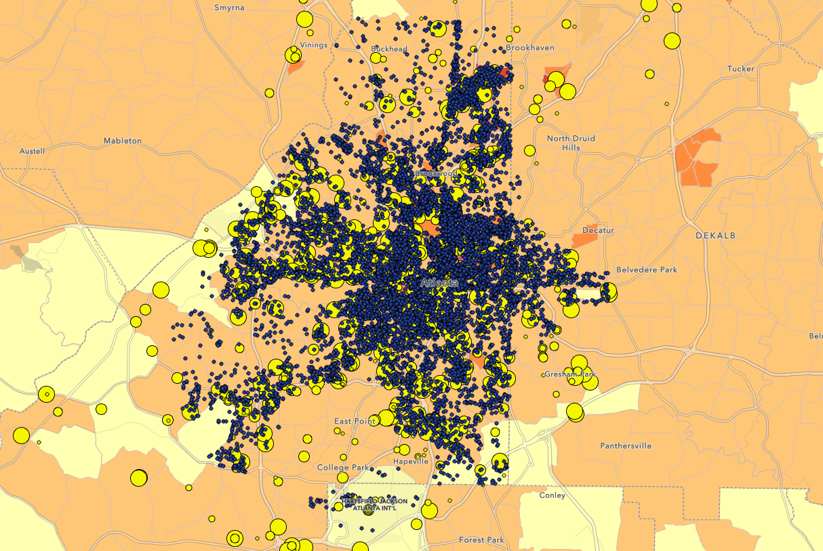

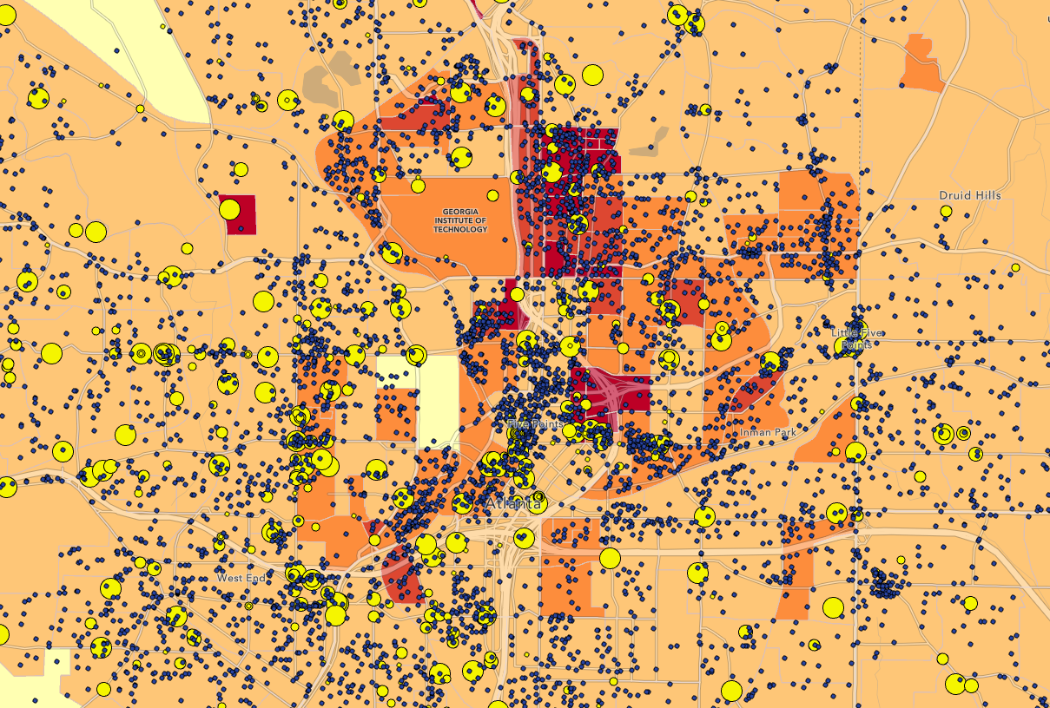

Gun violence follows all crime, although the rates isn’t consistent

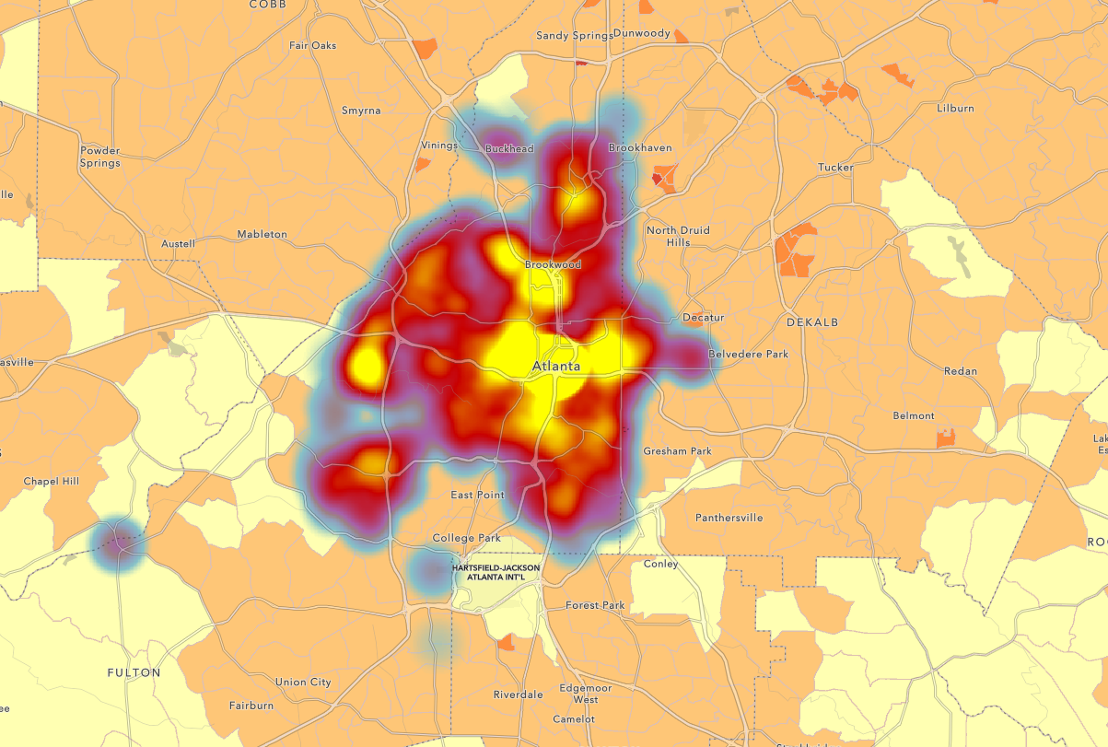

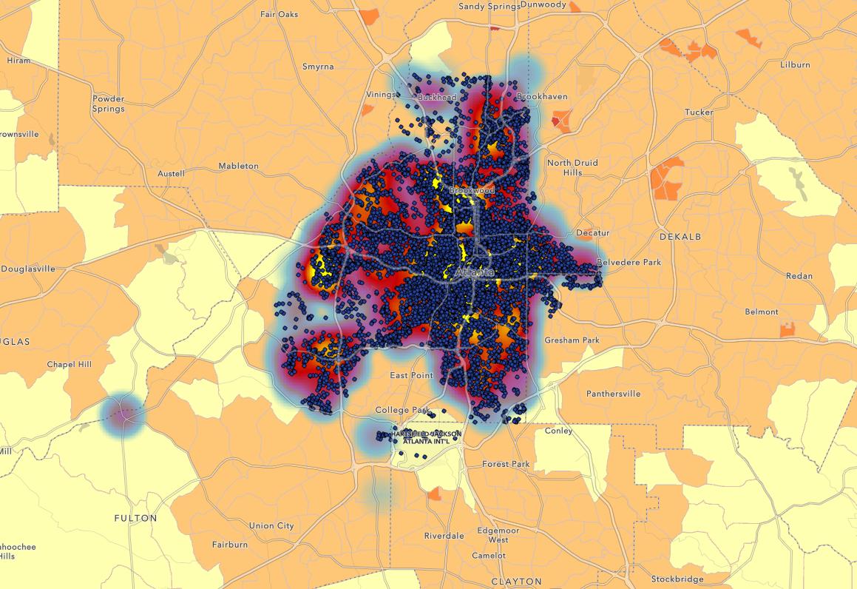

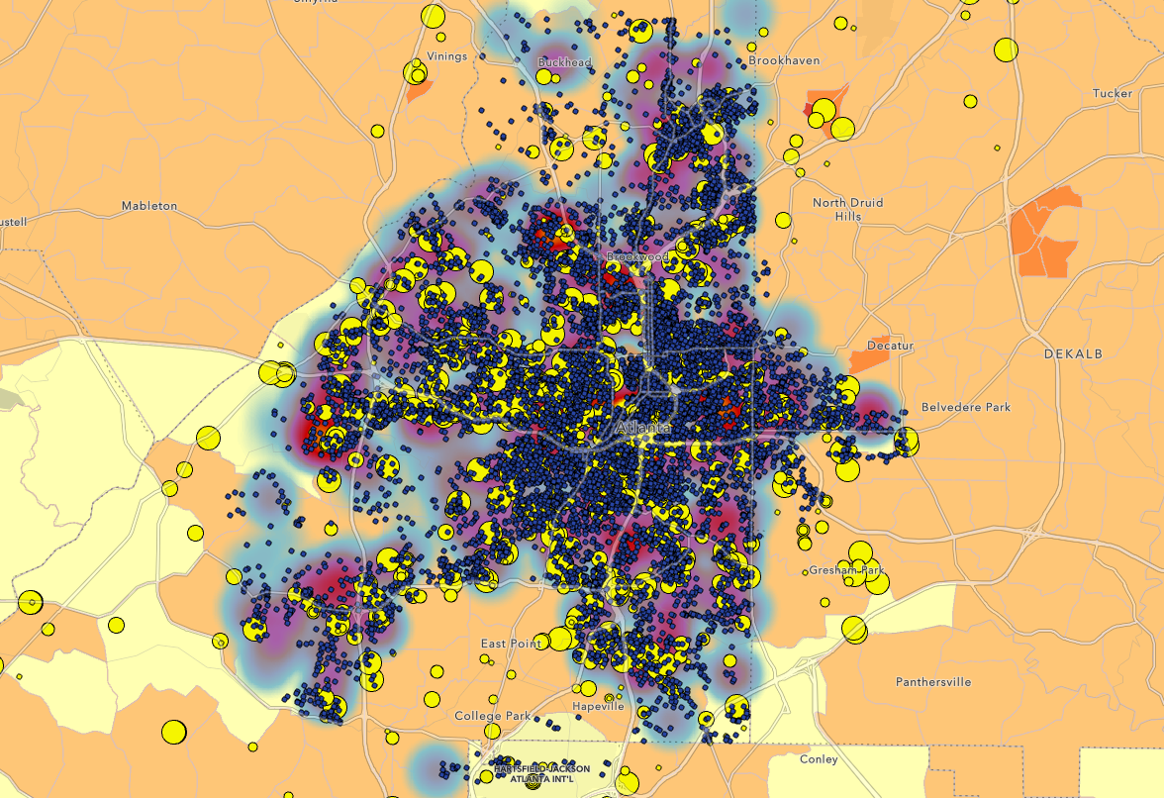

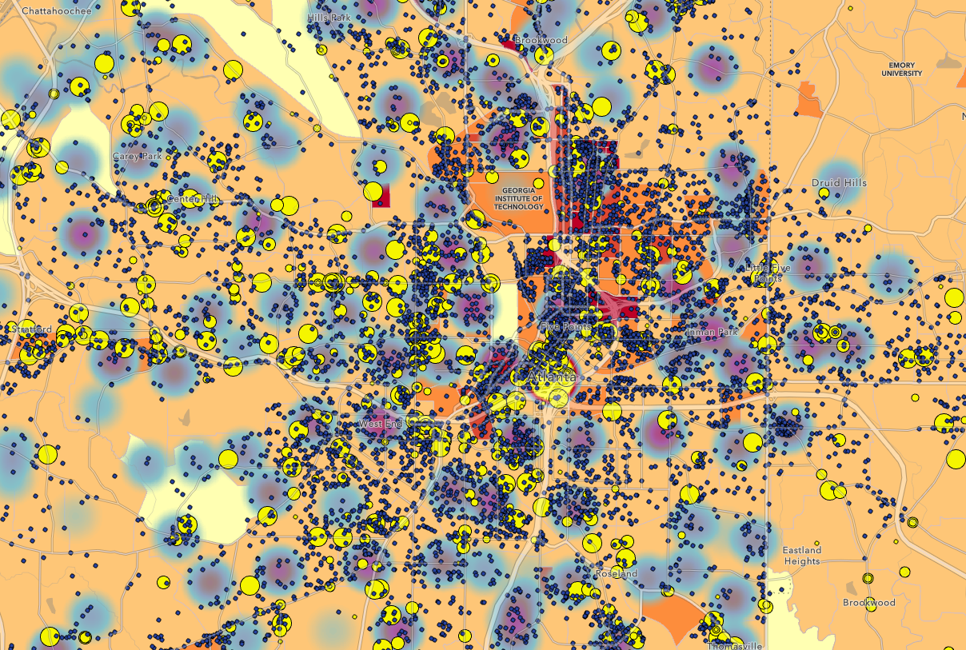

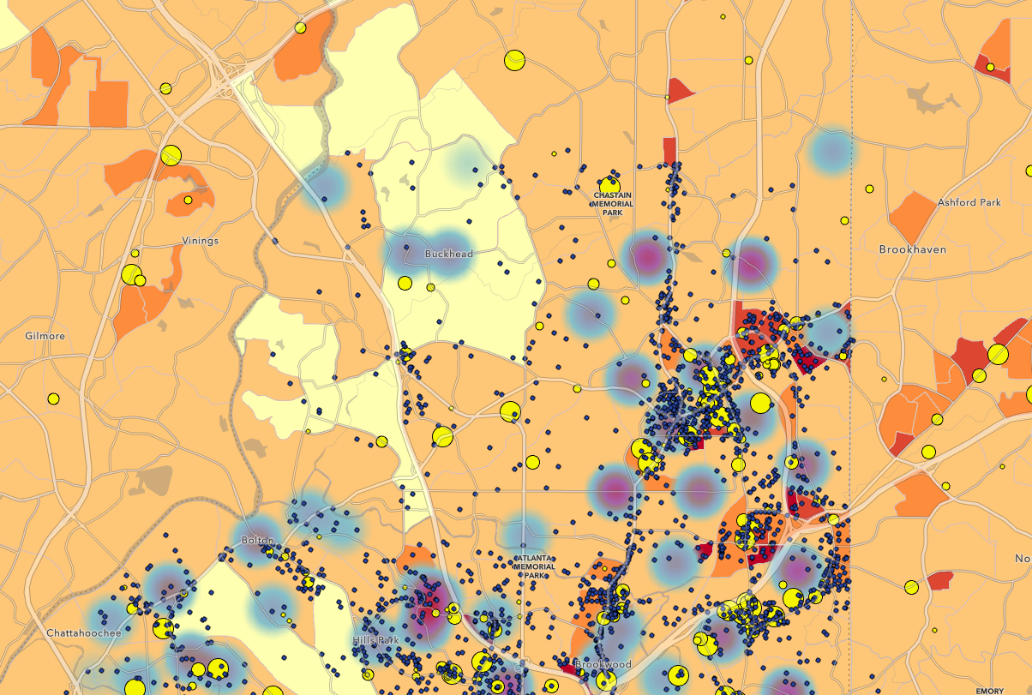

This is poverty map. The redder to yellow means the poorer the area is. And we can see from here that as gun violence follow crime, crime also follows poverty, while poverty follows population (in this case).